Write a biography of one of The Beatles and either:  - create a record sleeve for one of their songs after having listened to a few to decide on one.  Or  - write an adventure story set aboard their ‘yellow submarine’ you might get ideas from this video https://www.youtube.com/watch?v=m2uTFF_3MaA | 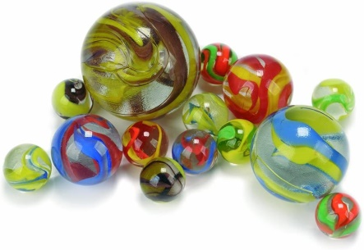  Design, play and write instructions for a game for marbles | 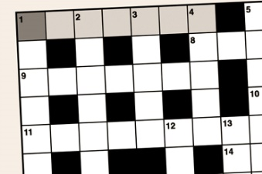  Create a crossword or wordsearch in a 20 x 20 grid (drawing the grid carefully with 1cm squares) to show knowledge of one area of science studied; sound, digestion, teeth or electricity - you choose which | We set the class the task of creating a times table quiz on scratch - it has to have scratch moving along a path or across a screen, questions and answers and something to stop scratch being successful, a trap or a timer or similar. This can be as complicated as you like.  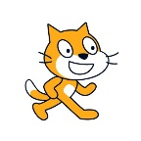  https://scratch.mit.edu/
Create a picture diary of the enforced time off school: we have done a computing unit of picture stories so this would consolidate that learning.  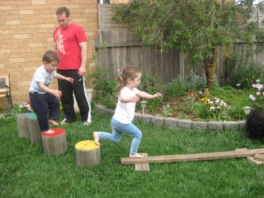  Hi | A guide or poster on how to keep your mind and body healthy in these strange circumstances - some good 'mindfulness' activities can be found on the Childline website, Joe wicks is an obvious one for physical well-being. | 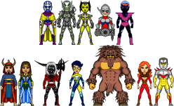  Create a new enemy for your favourite superhero; write a character description and illustrate with a picture of him/her/it. | Carry out a bird survey in the garden; make a graph or chart to show which birds visit your garden most often. Either carry it out for one hour or look outside every hour through the day.
Write and illustrate a book! Add to the Famous five list of adventure stories, it might be called  ‘Famous Five on a Mission’ | Write a poem.  See Mrs Newsome’s attempts – I’m sure you can do better! | Research a new artist and create a piece of art in their style OR create a new Arcimboldo picture. | Learn a new skill such as knitting or origami and create something – send us in your pictures.

